

FACULTY OF ENGINEERING AND TECHNOLOGY

A REPORT ON NUMERICAL METHODS: CREATING AND PROCESSING A STRUCTURAL ARRAY OF TEN LEAVES IN MATLAB.

COURSE UNIT: COMPUTER PROGRAMMING

LECTURER: Mr. MASERUKA BENEDICTO
SUBMITTED BY

GROUP 4

DATE OF SUBMISSION: …05/10/26
DECLARATION
We hereby certify and confirm that the information in this report is out of our own efforts, research and it has never been submitted in any institution for any academic award
No. | Name | Registration No.
1 | ECHOGEYA BILLY PAUL | BU/UP/2025/2086
2 | BAGONZA DERRICK | BU/UP/2025/4622
3 | LEWICH DERRICK | BU/UG/2025/0011
4 | KATO ENOS KIBAZO JACOB | BU/UP/2025/2088
5 | ARIBA MUDASIRI | BU/UG/2024/5902

APPROVAL
We are presenting this report which has been written and produced under our efforts. We carried out a group assignment in MATLAB in which a structural array describing ten different leaves was created, and each leaf image was processed to obtain a binary mask and basic geometric measurements.
ACKNOWLEDGEMENT
First and foremost, we would like to thank the Almighty God for giving us the strength to carry on with our research as Group 4. We would love to extend our gratitude to all the persons with whose help we managed to make it this far
The willingness of each one of us to invest time and provide constructive feedback has been immensely valuable in this assignment.
Finally, we would like to express our gratitude to all the sources and references that have been cited in this report
DEDICATION.
We dedicate this report to all the individuals especially Group 4 MEB members, who have been there for us in the process of formulating and producing this report.
To our lecturer Mr. Maseruka Benedicto whose guidance and expertise have been invaluable, your mentorship and insightful feedback have shaped our understanding.
ABSTRACT
This report presents a MATLAB group assignment on structural arrays and basic image processing. A structural array named Leaves was created to store the scientific name, common name, shape, margin, venation and photograph of ten different leaves. Each photograph was converted to grayscale, thresholded, cleaned and measured, and the resulting mask and measurements were stored in the same array.
The structural array stored mixed text, image and numeric data without difficulty. The threshold-based segmentation, however, depended strongly on the image background and gave dependable masks only for some of the leaves.
Table of Contents
INTRODUCTION 10
OBJECTIVES 10
The Assignment 22
Question 1: Newton–Raphson Method 23
Q1 Solution – Newton’s iterations 23
Starting value x₀ = 0.5 23
Starting value x₀ = 1.6 23
Q1 Flowchart – Newton–Raphson Method 25
How it works 25
Q1 Pseudocode 26
“for” loop 26
“while” loop 26
Q1 Code – “for” loop (MATLAB) 28
Q1 Code – “while” loop (MATLAB) and output 28
Output (same for both loops) 29
Question 2: Secant Method 30
Q2 Solution – Secant iterations 30
Q2 Flowchart – Secant Method 31
How it works 31
Q2 Pseudocode 32
“for” loop 32
“while” loop 32
Q2 Code – “for” loop (MATLAB) 34
Q2 Code – “while” loop (MATLAB) and output 34
Output (same for both loops) 35
Question 3: Fourth-Order Runge–Kutta (RK4) 36
Q3 Solution – RK4 (h = 0.2) 36
Step-by-step RK4 computation (h = 0.2) 36
RK4 result compared with the exact solution 36
Q3 Flowchart – Fourth-Order Runge–Kutta (RK4) 38
How it works 38
Q3 Pseudocode 39
“for” loop 39
“while” loop 39
Q3 Code – “for” loop (MATLAB) 41
Q3 Code – “while” loop (MATLAB) and output 41
Output (same for both loops) 42
Summary of Results 43

LIST OF ACRONYMS/ ABBREVIATIONS.
- RGB - Red, Green, Blue.
- MATLAB - Matrix Laboratory.

INTRODUCTION
A structural array in MATLAB stores related records in a single variable, with every element holding the same named fields. This is useful when each item being described has several attributes of different types, such as text, images and numbers. This report covers a group assignment in which such an array was used to organise information about ten leaves collected by the group, and in which each leaf photograph was processed with basic image-processing functions. The report covers:
- The design of a structural array named Leaves with fields for the scientific name, common name, shape, margin, venation and image of each leaf.
- The conversion of each image to a binary mask and the measurement of its area, perimeter, eccentricity and solidity.
- The display of the original images and masks, and a summary table of the whole array.
For each part, this report presents the method, the MATLAB code, and the results obtained.

OBJECTIVES
- To create a structural array that stores descriptive attributes and the photograph of ten different leaves.
- To process each leaf image into a binary mask using grayscale conversion, thresholding, hole filling and removal of small objects.
- To extract geometric measurements from each mask and store them in the structural array.
- To display the original images, processed masks and a summary table, and to discuss how reliable the results are.

ASSN 1
RegNo ={'BU/UP/2025/2088';'BU/UG/2025/2534';'BU/UP/2025/3821';'BU/UP/2025/2045';'BU/UG/2025/5902';'BU/UP/2025/0432';'BU/UP/2025/0972';'BU/UP/2025/0425';};
Name ={'Enos Jacob Kibazo';'Lewich Derrick';'Bagonza Derrick';'Echogeya Billy Paul';'Ariba Mudasiri';'Abdui Bosco';'Ayoma Morgan';'Kasule Betty';};
Gender={'Male';'Male';'Male';'Male';'Male';'Male';'Male';'Female';};
Age={20;21;26;22;27;23;29;24};
Tribe={'Muganda';'Iteso';'Batoro';'Samia';'Lugbara';'Alur';'Arua';'Kapchirwa';};
Homedistrict={'Wakiso';'Lira';'Fort Portal';'Busia';'Maracha';'Nebbi';'Lugbara';'Karamojong';};
Studentsdata=table(RegNo,Name,Gender,Age,Tribe,Homedistrict)
importdata=readtable("C:\Users\MUDASIRI\OneDrive\Desktop\MINING GROUP D\Mining group Mat lab.xlsx");
disp(importdata)
writetable(importdata,'Meb2 groupD.xlsx');
histogram(importdata.Age);
title('Age distribution of students');
xlabel('Age');
ylabel('Number of students')
exportgraphics(gcf,'Age_Distribution.png');
histogram(categorical(importdata.Gender));
title('Students by Gender');
xlabel('Gender');
ylabel('Number of Students');
exportgraphics(gcf,'Students_by_Gender.png');
bar(categorical(importdata.Name),importdata.Age);
title('Age Against Names of students');
xlabel('Names');
ylabel('Age(years)');
xtickangle(45);
grid;
exportgraphics(gcf,'Age_Against_Names.png');
ASSN 2
clc;
clear;

n = input('Enter number of semesters: ');

totalPoints = 0;
totalCredits = 0;

for s = 1:n

fprintf('\nSemester %d\n', s);

courses = input('Enter number of courses: ');

semesterPoints = 0;
semesterCredits = 0;

for i = 1:courses

fprintf('\nCourse %d\n', i);

credit = input('Enter credit units: ');
grade = input('Enter grade point: ');

semesterPoints = semesterPoints + (credit * grade);
semesterCredits = semesterCredits + credit;

end

GPA = semesterPoints / semesterCredits;

fprintf('\nGPA for Semester %d = %.2f\n', s, GPA);

totalPoints = totalPoints + semesterPoints;
totalCredits = totalCredits + semesterCredits;

end

CGPA = totalPoints / totalCredits;

fprintf('\nCGPA = %.2f\n', CGPA);

ASSN 3
%% Importing Our Data From Assignment One
StudentData=readtable("C:\Users\REDIM\Desktop\Mining Group Matlab.xlsx");
figure;
plot(StudentData.Age,StudentData.Marks);
xlabel('Age');
ylabel('Marks');
title('Line graph showing Marks against Age');
grid on;
%% Bar Graph
figure;
bar(StudentData.StudentsName,StudentData.Marks);
xlabel("StudentName");
ylabel("Marks");
title("Bar graph showing Marks against StudentName");
grid on;
%% scatter plot
figure;
scatter(StudentData.Age,StudentData.Marks);
xlabel("Age");
ylabel('Marks');
title('Scatter plot showing Marks against Age');
grid on;
%% Horizontal Bar graph
c%% Stem plot
figure;
stem(StudentData.Age,StudentData.Marks);
xlabel("Age");
ylabel('Marks');
title('Stem plot showing Marks against Age');
grid on;
%% step plot
figure;
stairs(StudentData.Age,StudentData.Marks);
xlabel("Age");
ylabel('Marks');
title('Step plot showing Marks against Age');
grid on;
%% Error bar Bar Plot

figure;
errorbar(StudentData.Age,StudentData.Marks);
errors=rand(19,23);
xlabel("Age");
ylabel('Marks');
title('Error bar plot showing Marks against Age');
grid on;
%% Area plot
figure;
area(StudentData.Age,StudentData.Marks);
xlabel("Age");
ylabel('Marks');
title('Area plot showing Marks against Age');
grid on;
%% Histogram
figure;
histogram(StudentData.Marks);
xlabel("StudentName");
ylabel('Marks');
title('Histogram showing Marks against StudentName');
grid on,
%% Pareto chart
figure;
pareto(StudentData.Marks);
xlabel("Age");
ylabel('Marks');
title('Pareto chart showing Marks against Age');
grid on;
%% Box plot
figure;
boxplot(StudentData.Marks);
xlabel("Age");
ylabel('Marks');
title('Pareto chart showing Marks against Age');
grid on;
%% pie chart
figure
pie(StudentData.Marks);
title('Pie chart showing students marks');
grid on;
%% pie chart with percentage lables

figure
lables=(StudentData.StudentsName);
pie(StudentData.Marks, lables);
title('Pie chart showing students marks');
grid on;
%% Logarithmic plot
figure;
semilogx(StudentData.Age,StudentData.Marks);
title('semilogx plot showing Marks against Age');
grid on;

ASSN 4
leaves(1).id = 1;
leaves(1).commonname = 'Mango'
leaves(1).shape = 'Lanceolate'
leaves(1).colour ='Green'
leaves(1).leaftype = 'simple'

leaves(2).id = 2;
leaves(2).commonname = 'Banana'
leaves(2).shape = 'Oblong'
leaves(2).colour ='Green'
leaves(2).leaftype = 'simple'

leaves(3).id = 3;
leaves(3).commonname = 'Cassava'
leaves(3).shape = 'Palmate'
leaves(3).colour = 'Green'
leaves(3).leaftype = 'simple'

leaves(1).originalimage= 'mango.jpg';
leaves(1).grayimage= 'mango_gray.png';
leaves(1).binaryimage='mango_binary.png';
leaves(1).edgeimage='mango_egde.png';

leaves(2).originalimage= 'banana.jpg';
leaves(2).grayimage= 'banana_gray.png';
leaves(2).binaryimage='banana_binary.png';
leaves(2).edgeimage='banana_egde.png';

leaves(3).originalimage= 'cassava.jpg';
leaves(3).grayimage= 'cassava_gray.png';
leaves(3).binaryimage='cassava_binary.png';
leaves(3).edgeimage='cassava_egde.png';

leaves(1).pixelarea= NaN;
leaves(1).pixelperimeter=NaN;

leaves(2).pixelarea= NaN;
leaves(2).pixelperimeter=NaN;

leaves(3).pixelarea= NaN;
leaves(3).pixelperimeter=NaN;

img= imread('leaf image processing/original images/banana.jpg');
figure;
imshow(img);
title('original banana leaf');
grayimg= rgb2gray(img);
figure;
imshow(grayimg);
title('grayscale banana leaf')
binaryimg= imbinarize(grayimg);
binaryimg = ~binaryimg
figure;
imshow(binaryimg);
title(' binary image')
cleanimg= bwareaopen(binaryimg,500);
figure;
imshow(cleanimg);
title('cleaned')
stats= regionprops(cleanimg,'Area','Perimeter');
leafarea= stats.Area;
leafperimeter= stats.Perimeter;
fprintf('leaf area:%.2f pixels\n',leafarea);
fprintf('leafperimeter:%.2f pixels\n',leafperimeter);
cassava = imread('leaf image processing/original images/cassava.jpg.jpg');

figure;
imshow(cassava);
title('Original Cassava Leaf');

cassavaGray = rgb2gray(cassava);

figure;
imshow(cassavaGray);
title('Grayscale Cassava Leaf');

cassavaBinary = imbinarize(cassavaGray, 'adaptive', ...
'ForegroundPolarity', 'bright', 'Sensitivity', 0.5);

figure;
imshow(cassavaBinary);
title('Binary Cassava Leaf');

cassavaCleaning = bwareaopen(cassavaBinary, 500);

cassavaCleaning = imfill(cassavaCleaning, 'holes');

figure;
imshow(cassavaCleaning);
title('Cleaned Cassava Leaf');

cassavaStats = regionprops(cassavaCleaning, 'Area', 'Perimeter');

fprintf('Number of detected cassava regions: %d\n', ...
numel(cassavaStats));

for k = 1:numel(cassavaStats)
fprintf('Region %d - Area: %.2f pixels, Perimeter: %.2f pixels\n', ...
k, cassavaStats(k).Area, cassavaStats(k).Perimeter);
end
mango = imread('leaf image processing/original images/mango.jpg.png');

figure;
imshow(mango);
title('Original Mango Leaf');

mangoGray = rgb2gray(mango);

figure;
imshow(mangoGray);
title('Grayscale Mango Leaf');

mangoBinary = imbinarize(mangoGray);

figure;
imshow(mangoBinary);
title('Binary Mango Leaf');

mangoCleaning = bwareaopen(mangoBinary, 500);

figure;
imshow(mangoCleaning);
title('Cleaned Mango Leaf');

mangoStats = regionprops(mangoCleaning, 'Area', 'Perimeter');

mangoArea = mangoStats.Area;
mangoPerimeter = mangoStats.Perimeter;

fprintf('Mango leaf area: %.2f pixels\n', mangoArea);
fprintf('Mango leaf perimeter: %.2f pixels\n', mangoPerimeter);

ASSN 5
Numerical Methods Assignment
Secant • Newton–Raphson • Runge–Kutta (RK4)

The Assignment
- Solve the math questions using the Secant, Runge–Kutta and Newton–Raphson methods.
- Give solutions using both a “for” loop and a “while” loop for each of the equations.
- Draw a flowchart and write the pseudocode for each method.
- All the work is to be presented in Word and PowerPoint.

Question 1: Newton–Raphson Method
Use Newton’s method to find the zeros of f(x) = 1 − 3x + ½ x e^{x} accurate to five decimal places.
Newton–Raphson formula: x_{n+1} = x_{n} − f(x_{n}) / f′(x_{n})
f(x) = 1 − 3x + ½ x e^{x} ⇒ f′(x) = ½ (1 + x) e^{x} − 3
x_{n+1} = x_{n} − (1 − 3x_{n} + ½ x_{n} e^{xₙ}) / (½ (1 + x_{n}) e^{xₙ} − 3)
Five decimal places ⇒ tolerance ε = 0.000005. Sketching f(x) shows two zeros, one near 0.5 and the other near 1.6, so we start from x₀ = 0.5 and x₀ = 1.6.

Q1 Solution – Newton’s iterations

Starting value x₀ = 0.5
n | x_{n} | |x_{n+1} − x_{n}|
0 | 0.500000
1 | 0.450200 | 0.049800
2 | 0.451541 | 0.001341
3 | 0.451542 | 0.000001

Starting value x₀ = 1.6
n | x_{n} | |x_{n+1} − x_{n}|
0 | 1.600000
1 | 1.552769 | 0.047231
2 | 1.549552 | 0.003217
3 | 1.549538 | 0.000014
4 | 1.549538 | 0.000000

- The zero close to 0.5 is x = 0.45154 (5 d.p.).
- The zero close to 1.6 is x = 1.54954 (5 d.p.).

Q1 Flowchart – Newton–Raphson Method
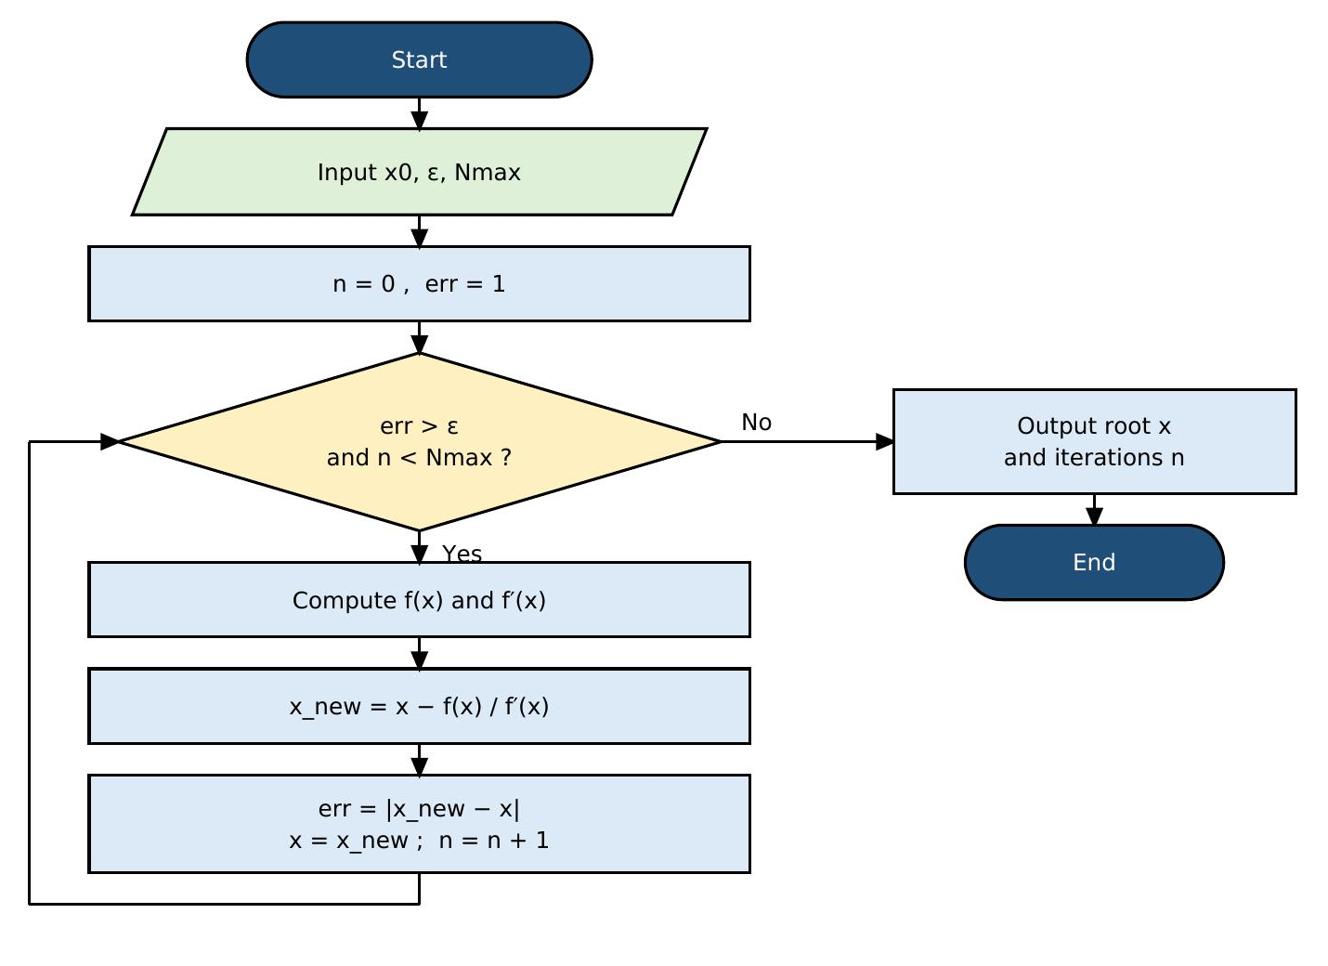

How it works
While-loop version shown. In the for-loop version the test is replaced by the counter n = 1 … Nmax, with an early exit (break) when err ≤ ε.

Q1 Pseudocode

“for” loop
INPUT x0, eps, Nmax
DEFINE f(x) = 1 - 3x + 0.5*x*e^x
DEFINE f'(x) = 0.5*(1 + x)*e^x - 3
x ← x0
FOR n = 1 TO Nmax DO
x_new ← x - f(x) / f'(x)
err ← |x_new - x|
OUTPUT n, x_new, err
IF err ≤ eps THEN
OUTPUT "Root =", x_new
STOP
END IF
x ← x_new
END FOR
OUTPUT "No convergence in Nmax steps"

“while” loop
INPUT x0, eps, Nmax
DEFINE f(x) = 1 - 3x + 0.5*x*e^x
DEFINE f'(x) = 0.5*(1 + x)*e^x - 3
x ← x0 ; n ← 0 ; err ← 1
WHILE err > eps AND n < Nmax DO
x_new ← x - f(x) / f'(x)
err ← |x_new - x|
x ← x_new
n ← n + 1
OUTPUT n, x, err
END WHILE
OUTPUT "Root =", x

Q1 Code – “for” loop (MATLAB)
% Q1: Newton-Raphson (FOR loop) f(x) = 1 - 3x + 0.5*x*e^x
clear; clc;
f = @(x) 1 - 3*x + 0.5*x.*exp(x);
df = @(x) 0.5*(1 + x).*exp(x) - 3;
tol = 0.000005; Nmax = 50;
starts = [0.5, 1.6];
for s = 1:numel(starts)
x = starts(s);
fprintf('x0 = %.1f\n', x);
fprintf('%2d %10.6f\n', 0, x);
for n = 1:Nmax
x_new = x - f(x)/df(x);
err = abs(x_new - x);
fprintf('%2d %10.6f %10.6f\n', n, x_new, err);
x = x_new;
if err <= tol
break
end
end
fprintf('Root = %.5f\n\n', x);
end

Q1 Code – “while” loop (MATLAB) and output
% Q1: Newton-Raphson (WHILE loop) f(x) = 1 - 3x + 0.5*x*e^x
clear; clc;
f = @(x) 1 - 3*x + 0.5*x.*exp(x);
df = @(x) 0.5*(1 + x).*exp(x) - 3;
tol = 0.000005; Nmax = 50;
starts = [0.5, 1.6];
for s = 1:numel(starts)
x = starts(s); n = 0; err = 1;
fprintf('x0 = %.1f\n', x);
fprintf('%2d %10.6f\n', 0, x);
while err > tol && n < Nmax
x_new = x - f(x)/df(x);
err = abs(x_new - x);
x = x_new;
n = n + 1;
fprintf('%2d %10.6f %10.6f\n', n, x, err);
end
fprintf('Root = %.5f\n\n', x);
end

Output (same for both loops)
x0 = 0.5
0 0.500000
1 0.450200 0.049800
2 0.451541 0.001341
3 0.451542 0.000001
Root = 0.45154

x0 = 1.6
0 1.600000
1 1.552769 0.047231
2 1.549552 0.003217
3 1.549538 0.000014
4 1.549538 0.000000
Root = 1.54954

Question 2: Secant Method
Find the positive solution of f(x) = x − 2 sin x = 0 by the secant method, starting with x₀ = 2 and x₁ = 1.9.
Secant formula: x_{n+1} = x_{n} − f(x_{n})(x_{n} − x_{n−1}) / (f(x_{n}) − f(x_{n−1})) = x_{n} − N_{n} / D_{n}
where N_{n} = f(x_{n})(x_{n} − x_{n−1}) and D_{n} = f(x_{n}) − f(x_{n−1}), with f(x) = x − 2 sin x.
Stopping rule: |x_{n+1} − x_{n}| < 0.0000005 (six decimal places). Starting values: x₀ = 2, x₁ = 1.9.

Q2 Solution – Secant iterations
n | x_{n−1} | x_{n} | N_{n} | D_{n} | |x_{n+1} − x_{n}|
1 | 2.000000 | 1.900000 | -7.400e-04 | -1.740e-01 | 0.004253
2 | 1.900000 | 1.895747 | -1.763e-06 | -6.985e-03 | 0.000252
3 | 1.895747 | 1.895495 | -2.719e-10 | -4.136e-04 | 0.000001
4 | 1.895495 | 1.895494 | -1.037e-16 | -1.077e-06 | 0.000000

- The positive root is x = 1.895494 (correct to 6 d.p.).
- No derivative is needed; only two starting values, and convergence is faster than linear.

Q2 Flowchart – Secant Method
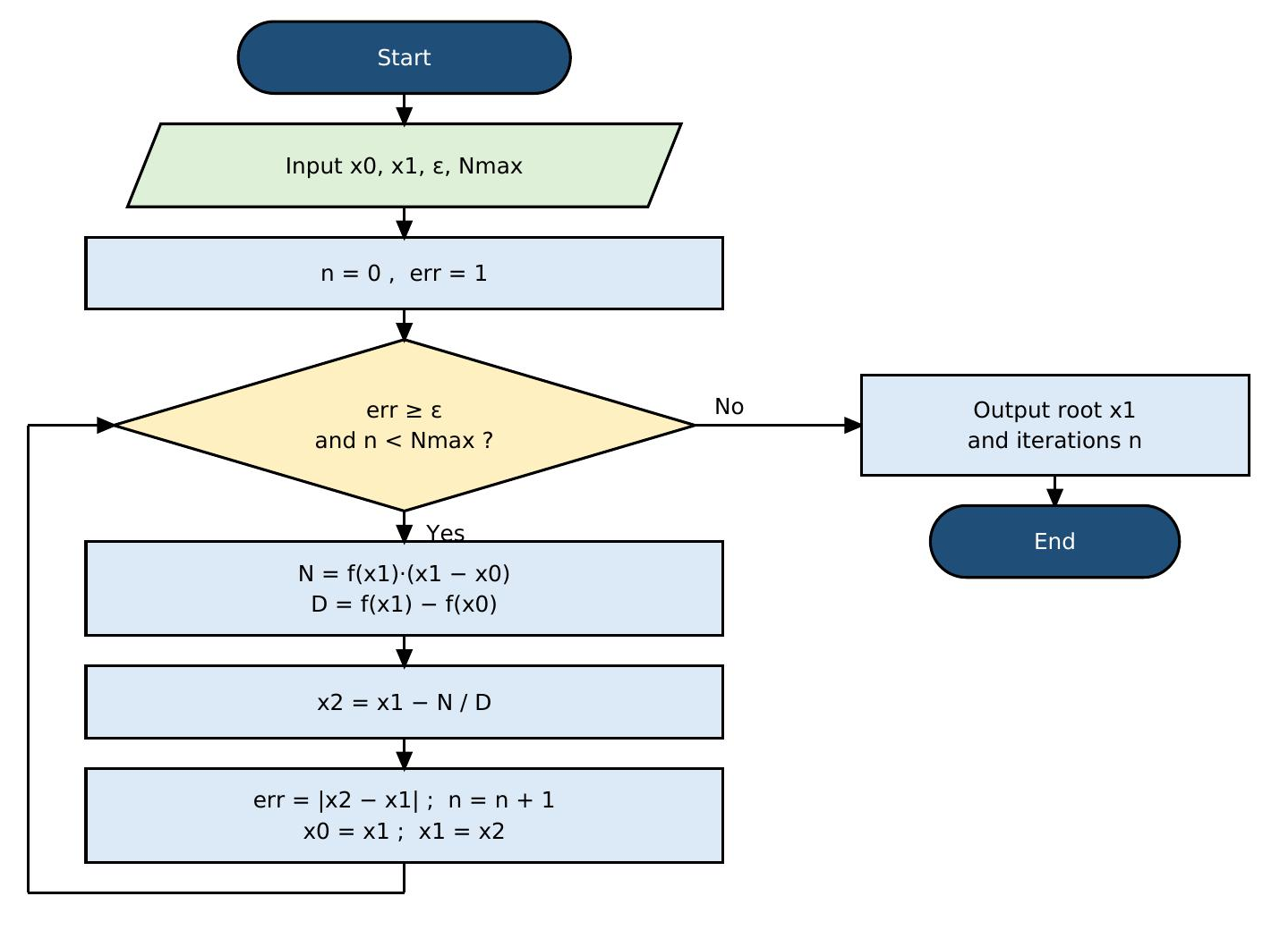

How it works
While-loop version shown. In the for-loop version the test is replaced by the counter n = 1 … Nmax, with an early exit (break) when err < ε.

Q2 Pseudocode

“for” loop
INPUT x0, x1, eps, Nmax
DEFINE f(x) = x - 2*sin(x)
FOR n = 1 TO Nmax DO
N ← f(x1) * (x1 - x0)
D ← f(x1) - f(x0)
IF D = 0 THEN STOP
x2 ← x1 - N / D
err ← |x2 - x1|
OUTPUT n, x0, x1, N, D, err
IF err < eps THEN
OUTPUT "Root =", x2
STOP
END IF
x0 ← x1
x1 ← x2
END FOR

“while” loop
INPUT x0, x1, eps, Nmax
DEFINE f(x) = x - 2*sin(x)
n ← 0 ; err ← 1
WHILE err ≥ eps AND n < Nmax DO
N ← f(x1) * (x1 - x0)
D ← f(x1) - f(x0)
IF D = 0 THEN STOP
x2 ← x1 - N / D
err ← |x2 - x1|
n ← n + 1
OUTPUT n, x0, x1, N, D, err
x0 ← x1
x1 ← x2
END WHILE
OUTPUT "Root =", x1

Q2 Code – “for” loop (MATLAB)
% Q2: Secant method (FOR loop) f(x) = x - 2 sin(x), x0 = 2, x1 = 1.9
clear; clc;
f = @(x) x - 2*sin(x);
x0 = 2; x1 = 1.9; tol = 0.0000005; Nmax = 50;
for n = 1:Nmax
N = f(x1)*(x1 - x0);
D = f(x1) - f(x0);
if D == 0
break
end
x2 = x1 - N/D;
err = abs(x2 - x1);
fprintf('%2d %9.6f %9.6f %11.3e %11.3e %10.6f\n', n, x0, x1, N, D, err);
x0 = x1; x1 = x2;
if err < tol
break
end
end
fprintf('Root = %.6f\n', x1);

Q2 Code – “while” loop (MATLAB) and output
% Q2: Secant method (WHILE loop) f(x) = x - 2 sin(x), x0 = 2, x1 = 1.9
clear; clc;
f = @(x) x - 2*sin(x);
x0 = 2; x1 = 1.9; tol = 0.0000005; Nmax = 50;
n = 0; err = 1;
while err >= tol && n < Nmax
N = f(x1)*(x1 - x0);
D = f(x1) - f(x0);
if D == 0
break
end
x2 = x1 - N/D;
err = abs(x2 - x1);
n = n + 1;
fprintf('%2d %9.6f %9.6f %11.3e %11.3e %10.6f\n', n, x0, x1, N, D, err);
x0 = x1; x1 = x2;
end
fprintf('Root = %.6f\n', x1);

Output (same for both loops)
1 2.000000 1.900000 -7.400e-04 -1.740e-01 0.004253
2 1.900000 1.895747 -1.763e-06 -6.985e-03 0.000252
3 1.895747 1.895495 -2.719e-10 -4.136e-04 0.000001
4 1.895495 1.895494 -1.037e-16 -1.077e-06 0.000000
Root = 1.895494

Question 3: Fourth-Order Runge–Kutta (RK4)
Example 4.5.3: Use the fourth-order Runge–Kutta algorithm with step size h = 0.2 to solve the initial value problem dy/dx + 2y = sin 3x with y(0) = 1 in the interval 0 ≤ x ≤ 2.4.
Rewrite as dy/dx = f(x, y) = sin 3x − 2y, x₀ = 0, y₀ = 1, h = 0.2 (12 steps to reach x = 2.4).
RK4 formulas: k₁ = h f(x_{n}, y_{n}), k₂ = h f(x_{n} + h/2, y_{n} + k₁/2), k₃ = h f(x_{n} + h/2, y_{n} + k₂/2), k₄ = h f(x_{n} + h, y_{n} + k₃)
y_{n+1} = y_{n} + (k₁ + 2k₂ + 2k₃ + k₄) / 6
First step (x₀ = 0, y₀ = 1): k₁ = -0.400000, k₂ = -0.260896, k₃ = -0.288717, k₄ = -0.171585 ⇒ y₁ = 0.721532.

Q3 Solution – RK4 (h = 0.2)

Step-by-step RK4 computation (h = 0.2)
n | x_{n} | y_{n} | k₁ | k₂ | k₃ | k₄ | y_{n+1}
0 | 0.0 | 1.000000 | -0.400000 | -0.260896 | -0.288717 | -0.171585 | 0.721532
1 | 0.2 | 0.721532 | -0.175684 | -0.096810 | -0.112585 | -0.057171 | 0.612924
2 | 0.4 | 0.612924 | -0.058762 | -0.033918 | -0.038887 | -0.034845 | 0.573054
3 | 0.6 | 0.573054 | -0.034452 | -0.049689 | -0.046642 | -0.075472 | 0.522623
4 | 0.8 | 0.522623 | -0.073957 | -0.108782 | -0.101817 | -0.140099 | 0.416748
5 | 1.0 | 0.416748 | -0.138475 | -0.170553 | -0.164138 | -0.189548 | 0.250514
6 | 1.2 | 0.250514 | -0.188710 | -0.200017 | -0.197755 | -0.195418 | 0.053902
7 | 1.4 | 0.053902 | -0.195876 | -0.177891 | -0.181488 | -0.148198 | -0.123237
8 | 1.6 | -0.123237 | -0.149938 | -0.105880 | -0.114692 | -0.059381 | -0.231648
9 | 1.8 | -0.231648 | -0.061894 | -0.005099 | -0.016458 | 0.043359 | -0.241923
10 | 2.0 | -0.241923 | 0.040886 | 0.091955 | 0.081741 | 0.126381 | -0.156146
11 | 2.2 | -0.156146 | 0.124767 | 0.153193 | 0.147508 | 0.162189 | -0.008087

RK4 result compared with the exact solution
n | x_{n} | y_{n} (RK4) | y exact | |error|
0 | 0.0 | 1.000000 | 1.000000 | 0.000000
1 | 0.2 | 0.721532 | 0.721415 | 0.000116
2 | 0.4 | 0.612924 | 0.612790 | 0.000134
3 | 0.6 | 0.573054 | 0.572955 | 0.000100
4 | 0.8 | 0.522623 | 0.522573 | 0.000050
5 | 1.0 | 0.416748 | 0.416737 | 0.000011
6 | 1.2 | 0.250514 | 0.250517 | 0.000003
7 | 1.4 | 0.053902 | 0.053892 | 0.000010
8 | 1.6 | -0.123237 | -0.123279 | 0.000042
9 | 1.8 | -0.231648 | -0.231725 | 0.000077
10 | 2.0 | -0.241923 | -0.242022 | 0.000100
11 | 2.2 | -0.156146 | -0.156244 | 0.000098
12 | 2.4 | -0.008087 | -0.008157 | 0.000070

- y(2.4) ≈ −0.008087 by RK4.
- Exact solution y = (2 sin 3x − 3 cos 3x)/13 + (16/13)e^{−2x} gives −0.008157, so the largest error is about 1 × 10⁻⁴.

Q3 Flowchart – Fourth-Order Runge–Kutta (RK4)
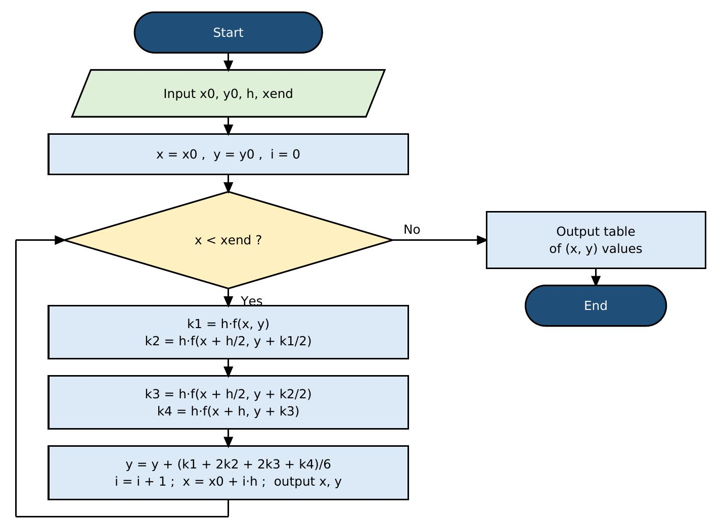

How it works
While-loop version shown. In the for-loop version the test is replaced by the counter i = 1 … steps.

Q3 Pseudocode

“for” loop
INPUT x0, y0, h, xend
DEFINE f(x, y) = sin(3x) - 2y
steps ← (xend - x0) / h
x ← x0 ; y ← y0
OUTPUT 0, x, y
FOR i = 1 TO steps DO
k1 ← h * f(x, y)
k2 ← h * f(x + h/2, y + k1/2)
k3 ← h * f(x + h/2, y + k2/2)
k4 ← h * f(x + h, y + k3)
y ← y + (k1 + 2*k2 + 2*k3 + k4) / 6
x ← x0 + i*h
OUTPUT i, x, y
END FOR

“while” loop
INPUT x0, y0, h, xend
DEFINE f(x, y) = sin(3x) - 2y
x ← x0 ; y ← y0 ; i ← 0
OUTPUT 0, x, y
WHILE x < xend DO
k1 ← h * f(x, y)
k2 ← h * f(x + h/2, y + k1/2)
k3 ← h * f(x + h/2, y + k2/2)
k4 ← h * f(x + h, y + k3)
y ← y + (k1 + 2*k2 + 2*k3 + k4) / 6
i ← i + 1
x ← x0 + i*h
OUTPUT i, x, y
END WHILE

Q3 Code – “for” loop (MATLAB)
% Q3: Runge-Kutta 4 (FOR loop) dy/dx = sin(3x) - 2y, y(0) = 1, h = 0.2, 0<=x<=2.4
clear; clc;
f = @(x,y) sin(3*x) - 2*y;
x0 = 0; y0 = 1; h = 0.2; xend = 2.4;
steps = round((xend - x0)/h);
x = x0; y = y0;
fprintf('%2d %4.1f %10.6f\n', 0, x, y);
for i = 1:steps
k1 = h*f(x, y);
k2 = h*f(x + h/2, y + k1/2);
k3 = h*f(x + h/2, y + k2/2);
k4 = h*f(x + h, y + k3);
y = y + (k1 + 2*k2 + 2*k3 + k4)/6;
x = x0 + i*h;
fprintf('%2d %4.1f %10.6f\n', i, x, y);
end

Q3 Code – “while” loop (MATLAB) and output
% Q3: Runge-Kutta 4 (WHILE loop) dy/dx = sin(3x) - 2y, y(0) = 1, h = 0.2, 0<=x<=2.4
clear; clc;
f = @(x,y) sin(3*x) - 2*y;
x0 = 0; y0 = 1; h = 0.2; xend = 2.4;
x = x0; y = y0; i = 0;
fprintf('%2d %4.1f %10.6f\n', i, x, y);
while x < xend - 1e-9
k1 = h*f(x, y);
k2 = h*f(x + h/2, y + k1/2);
k3 = h*f(x + h/2, y + k2/2);
k4 = h*f(x + h, y + k3);
y = y + (k1 + 2*k2 + 2*k3 + k4)/6;
i = i + 1;
x = x0 + i*h;
fprintf('%2d %4.1f %10.6f\n', i, x, y);
end

Output (same for both loops)
0 0.0 1.000000
1 0.2 0.721532
2 0.4 0.612924
3 0.6 0.573054
4 0.8 0.522623
5 1.0 0.416748
6 1.2 0.250514
7 1.4 0.053902
8 1.6 -0.123237
9 1.8 -0.231648
10 2.0 -0.241923
11 2.2 -0.156146
12 2.4 -0.008087

Summary of Results
Method | Problem | Result
Newton–Raphson | f(x) = 1 − 3x + ½ x e^{x} | x = 0.45154 and x = 1.54954
Secant | f(x) = x − 2 sin x | x = 1.895494
Runge–Kutta (RK4) | dy/dx + 2y = sin 3x, y(0) = 1 | y(2.4) ≈ −0.008087

Conclusion
In conclusion, this MATLAB assignment provided practical experience in using MATLAB commands and programming techniques to solve engineering and mathematical problem. The exercises improved our understanding of calculations, data manipulation, plotting,and the use of MATLAB functions.

